**MEDIA RESEARCH INTERNSHIP**

An INTERNSHIP REPORT

*Submitted by*

# Mr. / Ms. Asma Shaikh

*in partial fulfilment for the award of the degree*

*of*

# M.Sc. Statistics Semester - IV

# Academic year 2022 – 2023

*Submitted to*



## DEPARTMENT OF STATISTICS

## RAMNIRANJAN JHUNJHUNWALA COLLEGE OF ART’S,

**SCIENCE & COMMERCE (AUTONOMOUS),**

**GHATKOPAR (W)**

# RAMNIRANJAN JHUNJHUNWALA COLLEGE OF ART’S, SCIENCE & COMMERCE (AUTONOMOUS), GHATKOPAR (W)



***(Affiliated to University of Mumbai)***

**CERTIFICATE**

***This is to certify that the Mr. / Ms. Asma Shaikh* *has successfully completed the internship at Times Network during the year 2022-2023 in partial fulfilment of the requirements for the award of Degree Master of Science in Statistics.***

**Signature of Co-ordinator**

**Seal of the college**

**Signature of Examiner**

**ABSTRACT**

This internship report outlines the opportunities I have got to gain unique exposure to operations involved in the Research department of media company and enable me to get a broader perspective of working in a trend setting organization.

Working with Premier Media Company Times Network (BCCL), which dealt with all offline, online and broadcast media, I have worked on several Qualitative as well as Quantitative Data Analysis projects like Content Strategy on Election Result Day, Budget Day Content Planning, War Coverage, Movie Viewership Data Analysis etc. which are detailed below in this report, also digital media strategy on across various platform & domain.

Details of Working on Website and Social Media handle monitoring using various social media tools like Google Analytics, YouTube Analytics, comScore, Yumi Analytics (BARC) and forming everyday viewership data report are also broadly descripted in this report.

**ACKNOWLEDGEMENT**

I would like to express my sincere gratitude to Times Network for giving me the opportunity to be intern at their media company. I have learned a lot from working in this media research field and gained valuable skills and insights that will help me in my future career.

I specially want to thank my team lead, **Ms. Harini Venkatesan** (Deputy General Manager), for teaching me all the basics of my tasks and patiently showing me every elaborate detail and guiding me throughout my internship period. She was always available to answer my questions, provide constructive criticism and encourage me to challenge myself.

I would like to thank **Mr. Chandan Roy** (Senior Manager) for all his support, necessary tips and guidelines during the internship period, and the entire research team for being helpful and supportive in every little help I needed and for creating the opportunity for me to bring out my best performance.

Lastly, I would have to thank my friends who supported me during the preparation of this report and express my gratitude to everyone.

**INDEX**

|  |  |  |
| --- | --- | --- |
| **Sr. No.** | **Particulars** | **Page No.** |
| 1 | Abstract | 2 |
| 2 | Acknowledgement | 3 |
| 3 | About Times Network   * 1. Introduction   2. Recognitions | 5 |
| 4 | Qualitative Data Analysis   * 1. Introduction   2. Methodology   3. Project 1   4. Project 2   5. Project 3 | 7 |
| 5 | Quantitative Data Analysis   * 1. Introduction   2. Methodology   3. Analysis | 13 |
| 6 | Social Media Handle Monitoring Tools   * 1. Google Analytics   2. Creator Studio   3. Crowdtangle   4. Snapchat Handle   5. YouTube Analytics   6. Slike Analytics   7. comScore   8. YUMI (BARC) | 23 |
| 7 | Appendix 1 | 32 |
| 8 | Appendix 2 | 33 |

**ABOUT TIMES NETWORK**

**Introduction:**

The Times Network, with its credo ‘Now or Nothing’, is a pioneer in shaping opinions of opinion-makers by delivering the most compelling and irreplaceable content and latest news to the new-age audience. The network has stamped its leadership with differentiated content across multiple genres.

Times Network is the television division of Bennett, Coleman & Company Limited (BCCL) the parent company of India’s largest media conglomerate, the Times Group which owns and operates, inter alia, The Times of India, Economic Times and Mumbai Mirror, India’s leading print publications.

[Timesnownews.com](https://www.timesnownews.com/), the digital arm of Times Network, also owned and operated by BCCL, has seamlessly adapted itself to serve the diverse nature and interests of the content-savvy internet audience with fastest breaking news and latest news happenings and trends. The most comprehensive India news coverage makes it the go-to platform for accessing news that is sans bias and informative.

Times Network houses upscale brands including; TIMES NOW – India’s No. 1 English News channel, ET NOW – A News channel that helps you RISE WITH INDIA ; Mirror NOW - A news channel that solely focuses on the issues that impact YOU every day; MOVIES NOW and MOVIES NOW HD – India’s leading English Movies channel; MN+ – The Gold class of Hollywood; Romedy NOW and Romedy NOW HD – a unique destination for Love and Laughter; Zoom – India’s No. 1 Bollywood channel and the latest addition to the English Entertainment Cluster is MNX and MNX HD - The new age Hollywood channel for Young India. The network delivers segmented and differentiated content under one umbrella. It informs, entertains and engages over 100 million urban affluent viewers in India and is available in over 100 countries across the globe.

**Times Network has consistently created reputed brands to cater to top of the pyramid consumers.**

**Recognition:**

Times Network, India’s premium broadcast network, has been conferred top honours across categories at the recently concluded 13th Exchange4media News Broadcasting Awards (ENBA) 2020.

Celebrating the best of best in the Indian News broadcast industry and recognizing the tremendous work done by News channels during the pandemic year, ENBA 2020 felicitated broadcast players.

With 22 key wins at ENBA 2020, Times Network was recognized for its work in the News space during the pandemic-hit year and was fated for its public interest campaigns, which raised awareness against misinformation related to Covid-19. Times Network’s MD and CEO M K Anand was conferred ‘CEO of the year’ Award.

Two of Times Network’s initiatives – Pac Man Says, Stay Home. Stay Safe and Flatten the Curve – have won ENBA for ‘Best Channel/Program Promo’ for their messages of safety and caution during the pandemic. The Network’s pathbreaking initiative – fighting fear with facts - won ‘Best Campaign for Social Cause’, for its efforts to address growing misinformation about the pandemic.

The network that always prioritized the safety and well-being of its employees earned the special award for ‘New Processes for Employees Safety During Covid-19’.

TIMES NOW won the title of ‘News Channel of the year – English’. Mirror NOW, the channel that ‘Fights for You’ and focuses on issues that affect people’s lives, has bagged nine awards.

**Qualitative Data Analysis**

**Introduction:**

Qualitative Data Analysis is outlined as the method of consistently looking and composing the interview records, observation notes, or completely different non-textual materials that the investigator accumulates to increase the understanding of an event. The process of analysing qualitative data preponderantly involves writing or categorising the information. Primarily it involves making sense of massive amounts of data by reducing the amount of raw information, followed by distinctive important patterns, and eventually drawing meaningful knowledge and later building a logical pattern.

### **Types of Qualitative Analysis:**

This can be divided into the following five categories/types:

1. Content Analysis

2. Narrative Analysis

#### 3. Discourse Analysis

#### 4. Framework Analysis

#### 5. Grounded Theory

**Methodology:**

In this part of the report, I have mentioned three projects which I have worked on during the internship period using content analysis methods.

Below I have mentioned the description of the method followed and the details of final outcomes.

**Content Analysis:**

* This refers to the method of categorizing verbal or activity data to classify, summarize and tabulate the information.
* The content can be analysed on two levels:

1. Descriptive – What’s the data?
2. Interpretative – What was meant by the data?

* Using content analysis, researchers will quantify and analyse the presence, meanings, and relationships of such words, themes, or ideas.
* Content Analysis is employed to spot the intentions, focus or communication trends of a personal, cluster or establishment.
* Content Analysis is employed to explain attitudinal and behavioural responses to communications.
* It is employed to reveal patterns in communication content.
  1. **Gujarat Elections**

**Description:**

The Aim was to compare Times Now Navbharat (TNNB) Gujrat Elections coverage with competitions and preparation of report highlighting the difference of Graphics, Speech, Headlines, Accuracy of the on-air content, etc. to research about our strong and weak points than other competition channels.

pic - 1.1
The study was focused on 2022 Gujarat Elections.

Fig 1.1

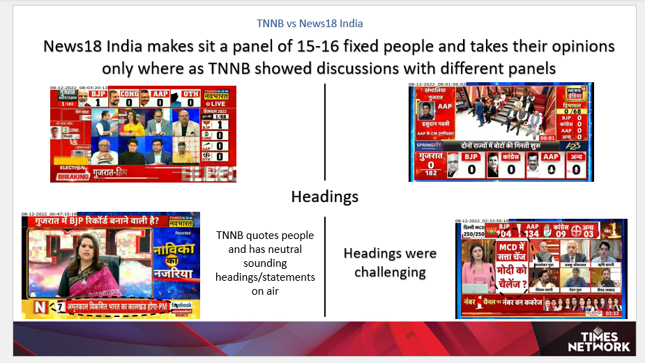Fig 1.2

Fig 1.3

Fig 1.1, 1.2, 1.3 are the images of prepared report after detailed research and analysis of asked contents.

* 1. **Budget Day Analysis**

**Description:**

This study was focused on the Budget Day (1st February 2022) on-air content of ET-Now and CNBC-TV18.

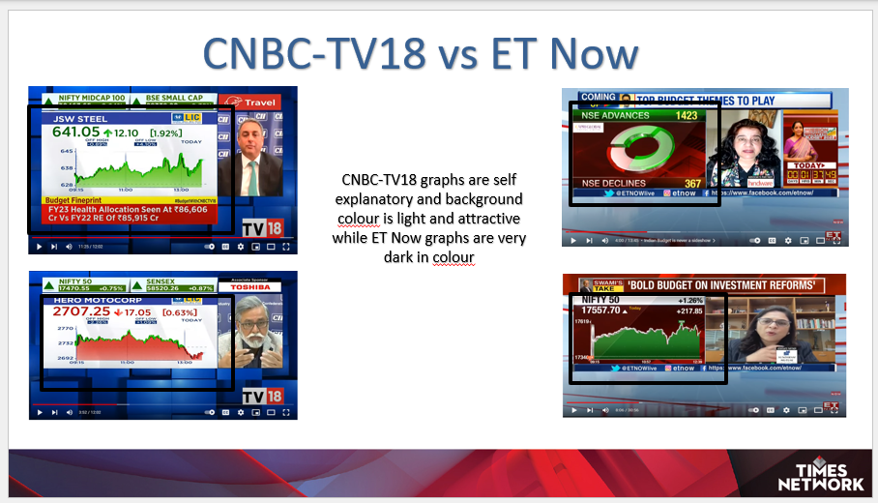The Aim was to compare Times Network’s business news channel ET Now with competition channel CNBC-TV18 and preparation of report highlighting the difference of Graphics, Speech, Headlines, Accuracy of the on-air content, etc. to research about our strong and weak points compared to competition channel.

Fig 2.1

Fig 2.1 is the image of the prepared report after doing the detailed research and analysis of the asked content.

* 1. **War Coverage**

**Description:**

Detailed data of December 2022 Russia-Ukrain war coverage of different channel, for different time slots was given (Fig 3.1).

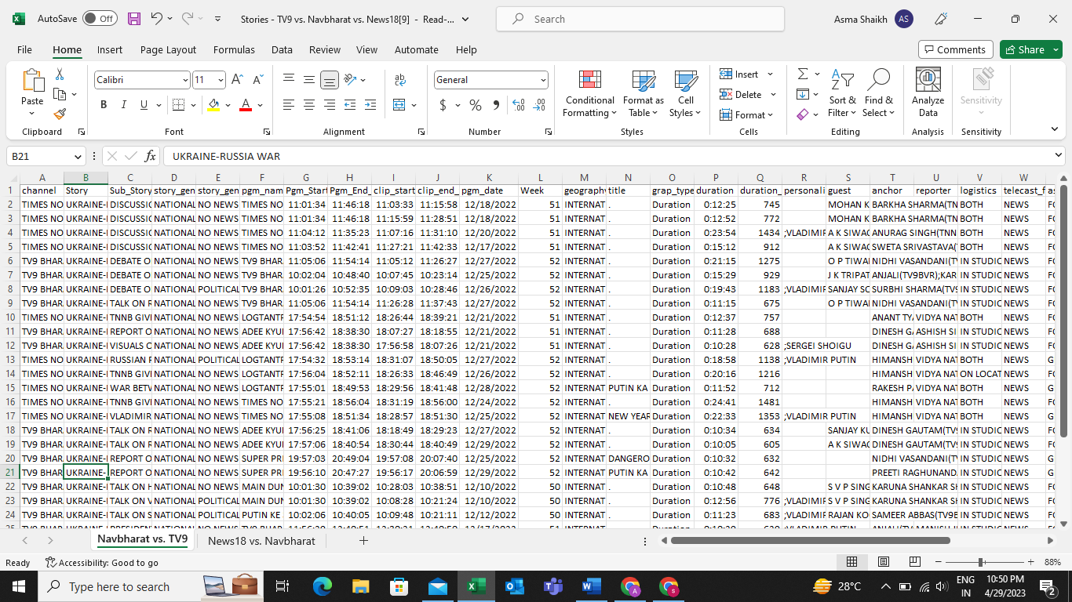The Aim was to compare Times Now Navbharat (TNNB) Russia-Ukrain war coverage with competitions and preparation of report highlighting the difference of Graphics, Speech, Headlines, Accuracy of the on-air content, etc. to research about our strong and weak points than other competition channels.

Fig 3.1

Fig 3.2

Fig 3.3

Fig 3.2 and Fig 3.3 are the images of the prepared report after doing detailed research of the content asked.

**Quantitative Data Analysis**

**Introduction:**

Despite being a mouthful, quantitative data analysis simply means **analyzing data that is numbers-based** – or data that can be easily “converted” into numbers without losing any meaning.

For example, [category-based variables](https://gradcoach.com/indepedent-dependent-variables/) like gender, ethnicity, or native language could all be “converted” into numbers without losing meaning – for example, English could equal 1, French 2, etc.

This contrasts against qualitative data analysis, where the focus is on words, phrases and expressions that can’t be reduced to numbers.

**Methodology:**

This analysis was aimed to compare our English Movie Channels with competition brands. I followed a multi-step approach that involves several key considerations.

Here are some steps that I have followed to design a sampling strategy for this objective:

**Step 1 –**

Exploratory Data Analysis (EDA)

Exploratory data analysis (EDA) is used by data scientists to analyze and investigate data sets and summarize their main characteristics, often employing data visualization methods. It helps determine how best to manipulate data sources to get the answers you need, making it easier for data scientists to discover patterns, spot anomalies, test a hypothesis, or check assumptions.

Primarily I have used EDA to see what data can reveal beyond the formal modeling or hypothesis testing task and how it provides a better understanding of data set variables and the relationships between them. It can also help me to determine if the statistical techniques I am considering for data analysis are appropriate.

**Step 2 –**

Descriptive Analysis

Descriptive analysis, also known as descriptive analytics or [descriptive statistics](https://descriptiveresearch.com/2019/descriptive-statistics/), is the process of using statistical techniques to describe or summarize a set of data. As one of the major types of data analysis, descriptive analysis is popular for its ability to generate accessible insights from otherwise uninterpreted data.

The reason that I used descriptive analysis method is that, unlike other types of data analysis, the descriptive analysis does not attempt to make predictions about the future. Instead, it draws insights solely from past data, by manipulating in ways that make it more meaningful.

**Step 3 –**

Predictive Analysis

Predictive analysis is just [one type of data analysis](https://pestleanalysis.com/data-analysis/), but it’s highly valued for the benefits it provides in making business decisions. In this report, I will outline the process of performing predictive analysis, and the conclusions I have got for the final product.

In any case, predictive analysis usually involves the use of various statistical models, techniques, and tools, all of which help to understand the patterns in datasets, and thus make predictions about the future.

Whereas some types of data analysis are only valuable in reviewing what has already happened, predictive analysis is all about making predictions. As a result, you can use predictive analysis whenever you feel the need to make predictions about the future.

Specifically, predictive analysis can be helpful when evaluating a business decision. This is because effective decision-making is all about understanding the consequences of decisions, based on predictions of how a venture, group, environment, or other entity will perform.

**Step 4 –**

Conclusion

Drawing conclusion and present them in an understandable format from the performed analysis is the most important part of any research. In this report, I have tried mentioning conclusions below only with each analysis.

**Step 5 –**

Dashboard building

I have been working on building a dashboard using Power BI that will help analyse and visualize the data from my research project. The goal of the dashboard is to provide a comprehensive overview of the data and facilitate data-driven decision-making. In this report, I will outline the process of building the dashboard, the key features, and the functionality of the final product.

**DATA ANALYSIS**

**Tool Used –**

* A screenshot of a computer

  Description automatically generated with medium confidencePython

Fig 4.1

Fig 4.1 shows the importation of provided detailed movie data in the python using appropriate python’s inbuilt libraries.

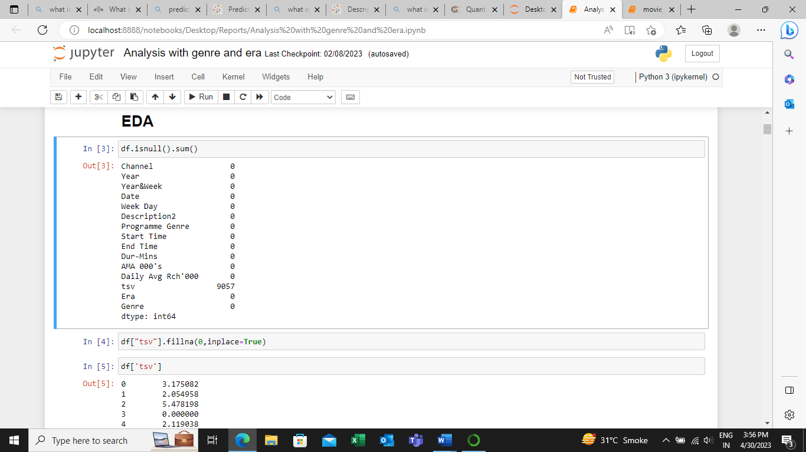Below Fig 4.2,4.3, 4.4 and 4.5 are showing descriptive statistics of the important variables, data distribution and information about number of movies made per era information respectively to better understand the data.

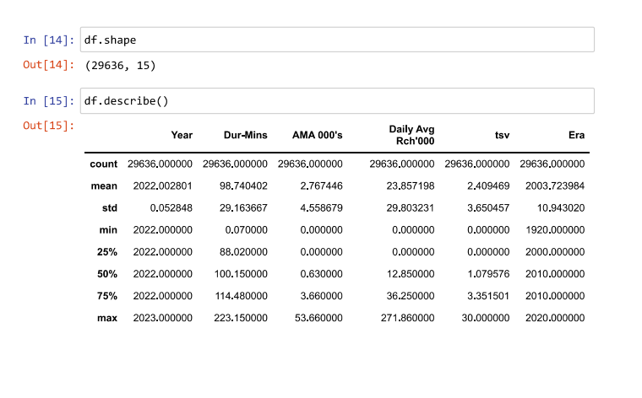Fig 4.2

Fig 4.3

Fig 4.4

Fig 4.5

Below Fig 4.6 shows Pearson correlation.

Fig 4.6

To see if there is a linear relationship b/w Dur-Mins and AMA 000's, I used the correlation coefficient of pearson and displayed the results in a table. With a coefficient of ~0.292 there is no evidence of a strong positive linear relationship b/w Dur-Mins and AMA 000's. However, the strongest linear relationship is evident b/w AMA 000's and Daily Avg Rch'000 ~0.767. It turns out that there is a strong linear relationship b/w AMA and Daily average reach. Movies with a high reach seem to have high AMA.

Figs 4.7, 4.8, 4.9 and 4.10 are the figures showing the python codes of few questions asked with the appropriate interpretations.

Fig 4.7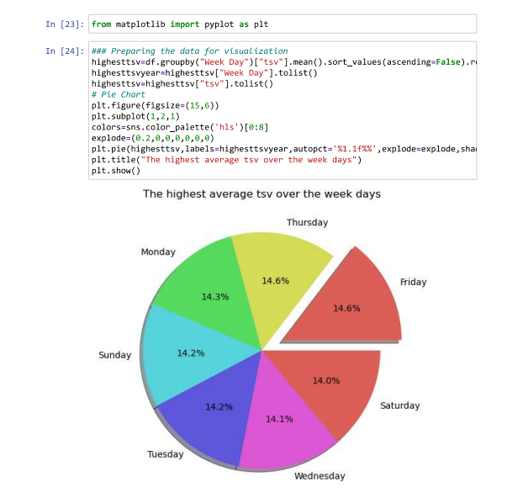

Fig 4.8

Fig 4.9

Fig 4.10

**Dashboard:**

**Process of Building the Dashboard:**

The process of building the dashboard using Google Data Studio involved several steps. First, we imported our research data into Google Sheets and connected it to Google Data Studio. This allowed us to create dynamic and interactive visualizations using the data in real time.

Next, we designed the dashboard layout and selected the appropriate charts and graphs to visualize the data. We also integrated various interactive features such as filters and drop-down menus to allow users to explore the data in more detail.

We then customize the appearance of the dashboard to match our research project’s branding and visual style. This included selecting the appropriate colour scheme, fonts, and graphics.

Finally, we tested the dashboard to ensure that it was functioning correctly, and that the data was being displayed accurately. We also gathered feedback from our research team to ensure that the dashboard met their needs and was user-friendly.

**Key Features and Functionality:**

The final dashboard created using Google Data Studio includes several key features and functionality that make it a powerful tool for data analysis. These features include:

1. **Data Export:** The dashboard includes the ability to export data in various formats such as Excel or CSV. This allows users to further analyse the data using their own preferred tools and software.
2. **Real-Time Data**: The dashboard updates in real-time as new data is added to Google Sheets. This allows users to monitor the data as it is collected and analysed.
3. **Interactive Filters**: The dashboard includes interactive filters that allow users to explore the data in more detail. Users can filter the data by various variables such as date range, demographic information, and smoking status.
4. **Multiple Visualisation Options:** The dashboard includes several visualization options such as bar charts, line graphs, and scatter plots. This allows users to select the most appropriate visualization for their data and analysis needs.
5. **Customizable Layout:** The dashboard layout is customizable, allowing users to select the most relevant data and charts to display. This makes the dashboard more user-friendly and tailored to the user’s needs.
6. **Data Sharing:** The dashboard can be shared with other members of the research team or external stakeholders, allowing them to view and interact with the data in real-time.

Building the dashboard was a challenging but rewarding experience. The final product provides a powerful tool for analysing and visualizing our research data and has been well-received by our research team. The dashboard’s interactive features, multiple visualization options, and customizable layout make it a versatile and user-friendly tool for data analysis. We are confident that the dashboard will help us draw meaningful conclusions from our data and facilitate data-driven decision-making.

Fig 4.11

**Overall:**

Fig 4.11 shows the Power BI dashboard image where using Interactive filters, I explore the data in more detail. Users can filter the data by various variables such as Genre & Channel information, Era wise information, etc.

**Website and Social Media Handle Monitoring Tools**

* **Google Analytics:**

Description of the tool:

Google Analytics, or GA, is a free analytics tool that gives you an in-depth look at your website and/or app performance. It integrates with Google's marketing and advertising platforms and products (including Google Ads, Search Console, and Data Studio) making it a popular choice for anyone using multiple Google tools.

Fig 4.12

Use:

To monitor daily performance of Times Network’s website we use Google Analytics to make daily report which has information about New Users, Page Views, Content wise website performance etc.

Fig 4.13

* **Creator Studio:**

Description of the tool:

Creator Studio is Facebook’s free dashboard that social media marketers and content creators can use to manage Facebook Pages and Instagram accounts. It brings together social media analytics, scheduling and community management. It also helps [eligible accounts](https://www.facebook.com/business/help/536194053479553?id=203539221057259) monetize their content and handle influencer-brand collaborations.

Use:

To monitor daily performance of Times Network’s Facebook Pages, Zoom, Times Now, TN Navbharat, The Foodie, Times Drive, Telly Talk, The Zoom Studios, Mirror Now, ET Now, TN+, ET Now Swadesh, Snazz Me Up, Gadget Times, TN Marathi I have use Creator Studio to make daily report which has information about daily views of the page.

Fig 4.14

* **CrowdTangle:**

Description of the tool:

CrowdTangle helps publishers identify great stories, measure social performance, and identify influencers. It's used by newspapers, television stations, digital media outlets, investigative journalists, entertainment companies, sports teams and non-profits all over the world. Hundreds of newsrooms and thousands of journalists use the tool every day.

Use:

To monitor daily performance of Times Network’s Official Instagram pages, Zoom, Times Now, TN Navbharat, The Foodie, Times Drive, Telly Talk, The Zoom Studios, Mirror Now, ET Now, TN+, ET Now Swadesh, Snazz Me Up, Gadget Times, TN Marathi we use CrowdTangle to make daily report which has information about daily views on each post, Likes, Followers etc. of the page.

Fig 4.15

* **Snapchat Handle:**

Description of the tool:

Snapchat Insights allows you to monitor and analyze your engagement on Snapchat and get detailed information about your audience. This will help you refine your [social strategy](https://blog.hootsuite.com/snapchat-for-business-guide/).

By measuring and understanding your Snaps’ performance, you can tweak and optimize your strategy on Snapchat for even bigger results. And, with the Snapchat analytics tool, you’ll be able to determine your return on investment quickly and easily.

Use:

To monitor daily performance of Times Network’s Snapchat Channels, Zoom, Times Now, TN Navbharat, The Foodie, Times Drive, Telly Talk, The Zoom Studios, Mirror Now, ET Now, TN+, ET Now Swadesh, Snazz Me Up, Gadget Times, TN Marathi we use Snapchat Analytics to make daily report which has information about daily views on each post of the Channel.

Fig 4.16

* **YouTube Analytics:**

Description of the tool:

YouTube Analytics allows you to monitor and analyze your engagement on Youtube and get detailed information about your audience. This will help you refine your [social strategy](https://blog.hootsuite.com/snapchat-for-business-guide/).

By measuring and understanding your Post’s performance, you can tweak and optimize your strategy on Youtube for even bigger results.

Fig 4.17

Use:

To monitor daily performance of Times Network’s Youtube Channels Zoom, Times Now, TN Navbharat, Times Foodie, Times Drive, Telly Talk India, The Zoom Studios, MIRROR NOW, ET NOW, TN Plus, ET Now Swadesh, Snazz Me Up, Gadget Times, TN Marathi, TIMES NOW WORLD we use Youtube Analytics to make daily report which has information about daily views on each post of the Channel.

* **Slike:**

Description of the tool:

Slike’s reporting dashboards provide you with deep analysis and insights for your real-time and historical data. Get comprehensive and easy to visualise detailed Video Analysis with Audience Retention, User engagement, Platform-wise distribution, Geographical analysis, Custom Reports, sources of content creator and much more.

Fig 4.18

Use: To monitor daily performance and content operation across the brand of Times Network’s website and App. This gives performance of content, advertisement run in those properties, nature of traffic (organic or paid), missed opportunity of advertisement,

Above table shows daily level performance of video across brand of Times together for the April month, which says performance of last few days is stable after drop from initial level of the month.



* **comScore:**

Description of the tool:

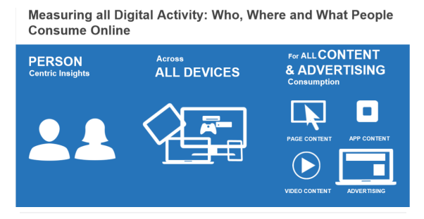comScore is a cross-platform media analytics tool that helps us capture vast audience insights across digital, linear TV, over-the-top (OTT) viewership. comScore helps media agencies, brands, and advertisers, broadcaster and content creator to combine their consumer data in different ways and ensure that advertising reaches to the right audience. Along with the reliable measurement of cross-platform audiences, comScore aims to provide advertisers with strategies to reach consumers based on more granular data.

Fig 4.19

Fig 4.20

Use: comScore data can be extremely useful for us as it provides valuable insights into audience behaviour and preferences. With comScore, we can track audience engagement, measure the effectiveness of their programming, and make data-driven decisions to improve content decision.

ComScore uses panel and beacon-based measurements depending on if the site they're measuring is a comScore subscriber. Subscribers are now required to have beacons on their site (a somewhat complicated version of a unique ID pixel). These beacons give comScore more accurate traffic data since they can be triggered on every page load vs. proxying traffic based on a small traffic sample from their panel members that happen to visit the site. ComScore still relies on their panel to double check their beacon numbers (bots, cookie clearing, etc) and to measure a site's audience (deeper demographic info, purchase behaviours). When looking at comScore's site metrics, the "normal" numbers we see are panel based while the "hybrid" numbers are a mix of their beacon and panel-based measurements.

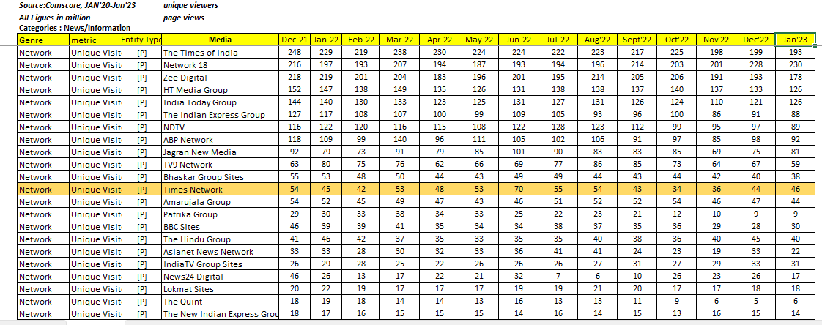ComScore provide data at monthly level along with entire competition across globe, which give ease to track comparison performance. below is the table for average monthly unique visitor who visited across brand of Times Group (BCCL) and competition. Which shows The Times of India on top of the list in most of the Month in last one year data. More than 190 Mn+ user visit across site every month.

Fig 4.21

* **YUMI (BARC)**

Description of the tool:

YUMI - BARC India's desktop software application is used to report and analyze audience viewership measurement data in the format required by individual customer segments.

BARC TV viewership software is a valuable tool for broadcasters and advertisers as it provides insights into the viewing habits of audiences. With BARC data, broadcasters can track the popularity of their programming, identify trends, and make informed decisions about scheduling and content. Advertisers can use BARC data to target their ads to specific audiences and measure the effectiveness of their campaigns. Additionally, BARC data can be used to negotiate advertising rates and inform programming decisions. Overall, BARC TV viewership data is a crucial resource for anyone involved in

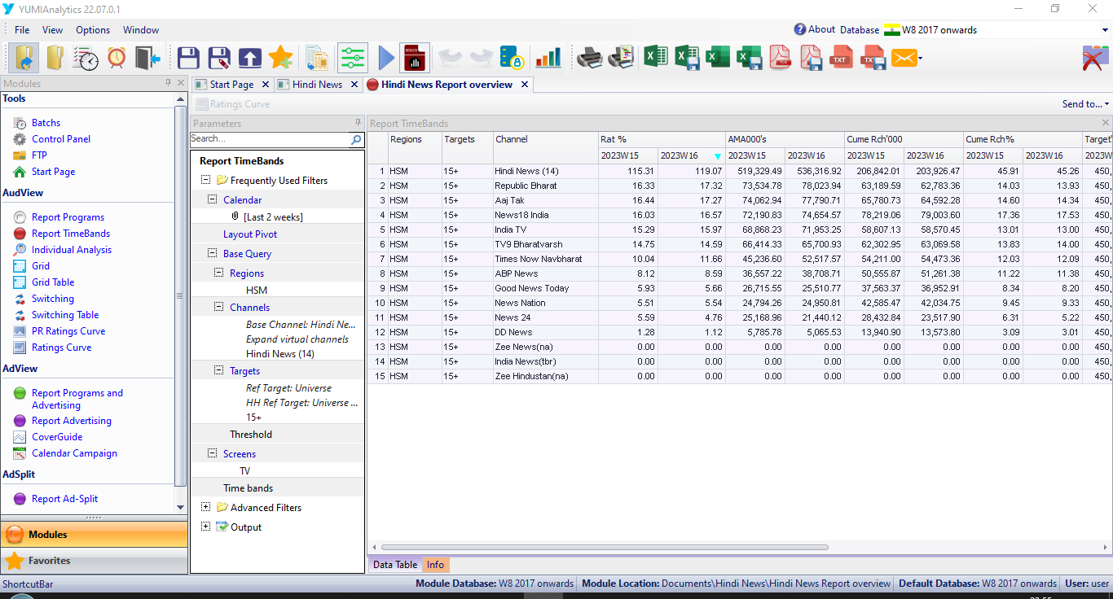 the television industry.

Fig 4.22

Use: above table 4.22 is one of the example of Time band module, which give slot/time band level insight of Hindi News Genre, it shows Weekly GRPs/Rat%, AMAs’000, Cum Reach’000, Ranking for Week 15 &16, in latest Week16 Republic Bharat is NO.1 channel in Hindi News Genre with 17.22 GRPs, Republic Bharat reaches to around 69 million viewers and Hindi News Genre reaches to more 23 crores Peoples.